[GOOGLE EARTH ENGINE](EE01%20Earth%20Engine%20(EE).docx) [APPLICATION PROGRAMMING INTERFACE](EE05%20%20%20The%20EE%20API.docx) [CAPABILITIES](EE07%20%20%20%20%20%20API%20Capabilities.docx)

PROCESSING **NUMBER** [VARIABLES](EE13%20%20%20%20%20%20%20%20%20Variables.docx)

A number is an EE variable object that represents a quantity. Numbers can be processed by using operations of the types listed below, which vary according to the nature of that processing. Each operation name is linked to a separate page describing that operation.

**CREATING** NUMBERS ee.Number

**EDITING** NUMBERS number.uint8  number.Uint8

BY **RECASTING** DATA TYPES number.uint16 number.Uint16 number.uint32 number.Uint32

number.int8 number.toInt8 number.byte  number.toByte

number.int16  number.toInt16 number.short  number.toShort

number.int32  number.toInt32 number.int number.toInt

number.int64  number.toInt64 number.long  number.toLong

number.float  number.toFloat number.double number.toDouble

**TRANSFORMING** NUMBERS

WITH **LOGICAL** OPERATIONS number.eq number.gt number.lt number.and

number.neq number.gte number.lte number.or

number.not

WITH **MATHEMATICAL** OPERATIONS number.abs number.ceil number.floor number.log

number.round number.sqrt number.exp number.log10 number.add number.subtract number.multiply number.divide

number.max number.min number.mod  number.pow

number.hypot number.first number.first_nonzero

WITH **TRIGONOMETRIC** OPERATIONS number.sin number.cos number.tan

number.sinh number.cosh number.tanh

number.acos number.asin number.atan number.atan2

WITH **BITWISE** OPERATIONS number.bitwiseAnd number.bitwiseOr number.bitwise_xor number.bitwiseNot

number.bitwise_and number.bitwise_or number.bitwiseXor number.bitwise_not

number.leftShift number.left_shift number.rightShift number.right_shift

**COMPARING** NUMBERS ee.Algorithms.IsEqual

**DOCUMENTING** NUMBERS ee.Algorithms.Describe ee.Algorithms.String number.GetInfo

number.toString number.serialize

**PRESENTING** NUMBERS

IN **PRINT** print(number) console.log(number) alert(number)  confirm(number)

[GOOGLE EARTH ENGINE](EE01%20Earth%20Engine%20(EE).docx) [APPLICATION PROGRAMMING INTERFACE](EE05%20%20%20The%20EE%20API.docx) [CAPABILITIES](EE07%20%20%20%20%20%20API%20Capabilities.docx)

**CREATING** NUMBER [VARIABLES](EE13%20%20%20%20%20%20%20%20%20Variables.docx)

ee.Number creates a new number from a specified sequence of numeral characters.

newNumber = ee.Number( characters )

The specified sequence of characters

The new number

var TheNUMBER = ee.Number( 123 );

print( TheNUMBER );

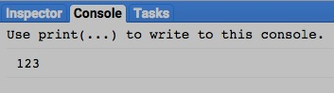

[GOOGLE EARTH ENGINE](EE01%20Earth%20Engine%20(EE).docx) [APPLICATION PROGRAMMING INTERFACE](EE05%20%20%20The%20EE%20API.docx) [CAPABILITIES](EE07%20%20%20%20%20%20API%20Capabilities.docx)

**EDITING** NUMBER [VARIABLES](EE13%20%20%20%20%20%20%20%20%20Variables.docx) BY **RECASTING** DATA TYPES

number.uint8 , .toUint8 , .byte , and .toByte unsigned 8-bit integers

.uint32 and .toUint32 unsigned 32-bit integers

.uint16 and .toUint16 unsigned 16-bit integers

Each of these operations replicates a specified number (of any numerical type) to create a new one whose pixel type is as indicated in red.

.int8 and .toInt8 signed 8-bit integers

.int16 , .toInt16 , .short , and .toShort signed 16-bit integers

.int32 , .toInt32 , .int , and .toInt signed 32-bit integers

.int64 , .toInt64 , .long , and .toLong signed 64-bit integers

.float and .toFloat 32-bit floating-point numbers

.double and .toDouble 64-bit floating-point numbers

newNumber = oldNumber.uint8( ) or .toUint8( ) or .byte( ) or .toByte( )

or .uint16( ) or .toUint16( )

or .int16( ) or .toInt8( ) or .short( ) or .toShort( )

The new number

or .uint32( ) or .toUint32( )

or .int8( ) or .toInt8( )

The specified number

or .int32( ) or .toInt32( ) or .int( ) or .toInt( )

or .int64( ) or .toInt64( ) or .long( ) or .toLong( )

or .float( ) or .toFloat( )

or .double( ) or .toDouble( )

var OldNUMBER = ee.Number( -123.456 );

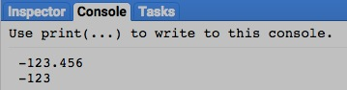var NewNUMBER = OldNUMBER.int8();

print( OldNUMBER, NewNUMBER );

[GOOGLE EARTH ENGINE](EE01%20Earth%20Engine%20(EE).docx) [APPLICATION PROGRAMMING INTERFACE](EE05%20%20%20The%20EE%20API.docx) [CAPABILITIES](EE07%20%20%20%20%20%20API%20Capabilities.docx)

**TRANSFORMING** NUMBER [VARIABLES](EE13%20%20%20%20%20%20%20%20%20Variables.docx) WITH **LOGICAL** OPERATIONS

number.eq , .neq , .gt , .gte, .lt , and .lte create a new number of 0 or 1 that characterizes a specified relationship between two specified numbers.

newNumber = 1stNumber.eq( 2ndNumber ) or .neq( ) or .gt( ) or .gte( ) or .lt( ) or .lte( )

The second specified number

The first specified number

The new number, set to 1 if the specified relationship is true or to 0 if it is false

The specified relationship, questioning whether the first specified number is equal to (**eg**), not equal to (**neq**),

greater than (**gt**), greater than or equal to (**gte**), less than (**lt**), or less than or equal to (**lte**) the second.

var FirstNUMBER = ee.Number( 123 );

var SecondNUMBER = ee.Number( -123 );

var TruthNUMBER = FirstNUMBER.eq( SecondNUMBER );

print( FirstNUMBER, SecondNUMBER )

print('Is it true(1) or false(0) that those two numbers are equal?' );

print( TruthNUMBER);

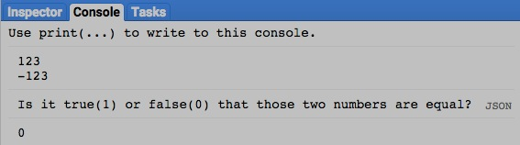

[GOOGLE EARTH ENGINE](EE01%20Earth%20Engine%20(EE).docx) [APPLICATION PROGRAMMING INTERFACE](EE05%20%20%20The%20EE%20API.docx) [CAPABILITIES](EE07%20%20%20%20%20%20API%20Capabilities.docx)

**TRANSFORMING** NUMBER [VARIABLES](EE13%20%20%20%20%20%20%20%20%20Variables.docx) WITH **LOGICAL** OPERATIONS

number.and and .or create a new number of 0 or 1 that indicates whether either or both of two specified numbers are non-zero.

newNumber = 1stNumber.and( 2ndNumber ) or .or( )

The second specified number

The first specified number

The specified relationship, questioning whether

*either* specified number is non-zero.

The specified relationship, questioning whether

*both* specified numbers are non-zero.

The new number, set to 1 if the specified relationship is true or to 0 if it is false

var FirstNUMBER = ee.Number( 123 );

var SecondNUMBER = ee.Number( -123 );

var TruthNUMBER = FirstNUMBER.eq( SecondNUMBER ).or

( FirstNUMBER.eq( SecondNUMBER.multiply(-1) ) );

print( FirstNUMBER, SecondNUMBER );

print('Is it true(1) or false(0) that the absolute values');

print('of those two numbers are equal?' );

print( TruthNUMBER);

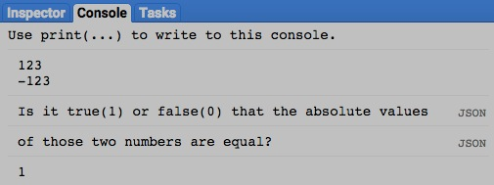

[GOOGLE EARTH ENGINE](EE01%20Earth%20Engine%20(EE).docx) [APPLICATION PROGRAMMING INTERFACE](EE05%20%20%20The%20EE%20API.docx) [CAPABILITIES](EE07%20%20%20%20%20%20API%20Capabilities.docx)

**TRANSFORMING** NUMBER [VARIABLES](EE13%20%20%20%20%20%20%20%20%20Variables.docx) WITH **LOGICAL** OPERATIONS

number.not creates a new number of 1 if a specified number is equal to 0 and to 0 if that specified number is not equal to 0.

newNumber = oldNumber.not( )

The new number

The specified number

var OldNUMBER = ee.Number( 123 );

var TruthNUMBER = OldNUMBER.not( );

print( OldNUMBER );

print('Is it true(1) or false(0) that this number is equal to 0?' );

print( TruthNUMBER );

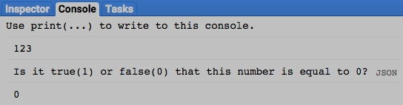

[GOOGLE EARTH ENGINE](EE01%20Earth%20Engine%20(EE).docx) [APPLICATION PROGRAMMING INTERFACE](EE05%20%20%20The%20EE%20API.docx) [CAPABILITIES](EE07%20%20%20%20%20%20API%20Capabilities.docx)

**TRANSFORMING** NUMBER [VARIABLES](EE13%20%20%20%20%20%20%20%20%20Variables.docx) WITH **MATHEMATICAL** OPERATIONS

number.abs , .round , .floor , .ceil , .sqrt , .exp , .log, and .log10 all create a new number by applying a specified

mathematical function to a specified number.

newNumber = oldNumber.abs( ) or .round( ) or .floor( ) or .ceil( ) or .sqrt( ) or .exp( ) or .log( ) or .log10( )

The specified mathematical function

The new number

The specified number

var OldNUMBER = ee.Number( -724.3352);

var NewNUMBER = OldNUMBER.floor().abs();

print ( OldNUMBER, NewNUMBER );

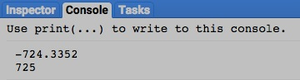

[GOOGLE EARTH ENGINE](EE01%20Earth%20Engine%20(EE).docx) [APPLICATION PROGRAMMING INTERFACE](EE05%20%20%20The%20EE%20API.docx) [CAPABILITIES](EE07%20%20%20%20%20%20API%20Capabilities.docx)

**TRANSFORMING** NUMBER [VARIABLES](EE13%20%20%20%20%20%20%20%20%20Variables.docx) WITH **MATHEMATICAL** OPERATIONS

number.add , .subtract , .multiply , .divide , .max , .min ,

.mod , .pow , .hypot , .first , and .first_nonzero

all create a new number by applying a specified mathematical function to two specified numbers.

newNumber = 1stNumber.add( 2ndNumber ) or .subtract( ) or .multiply( ) or .divide( ) or .max( ) or .min( )

or .mod( ) or .pow( ) or .hypot( ) or .first( ) or .first_nonzero( )

The first specified number

The second specified number

The specified mathematical function

The new number

var FirstNUMBER = ee.Number( 12 );

var SecondNUMBER = ee.Number( 25 );

var PctCHANGE = SecondNUMBER.subtract(FirstNUMBER).multiply(100.0).divide(FirstNUMBER);

print( FirstNUMBER, SecondNUMBER );

print( 'The 2nd number above represents an increase in the 1st number by the following %' );

print( PctCHANGE );

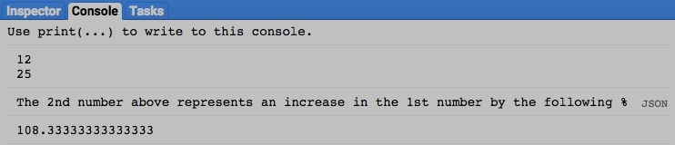

[GOOGLE EARTH ENGINE](EE01%20Earth%20Engine%20(EE).docx) [APPLICATION PROGRAMMING INTERFACE](EE05%20%20%20The%20EE%20API.docx) [CAPABILITIES](EE07%20%20%20%20%20%20API%20Capabilities.docx)

**TRANSFORMING** NUMBER [VARIABLES](EE13%20%20%20%20%20%20%20%20%20Variables.docx) WITH **TRIGONOMETRIC** OPERATIONS

number.sin , .cos , .tan , .sinh , .cosh , .tanh , .acos , .asin , and .atan all create a new number by applying

a specified trigonometric function to a specified number.

newNumber = oldNumber.sin( ) or .cos( ) or .tan( )

or .sinh( ) or .cosh( ) or .tanh( ) or .acos( ) or .asin( ) or .atan( )

The new

number

The specified number, assumed to be in radians

The specified trigonometric function

var DegreeNUMBER = 45;

var RadianNUMBER = ee.Number( DegreeNUMBER / 57.2957795 );

var TangentNUMBER = RadianNUMBER.tan();

print( DegreeNUMBER );

print( RadianNUMBER );

print( TangentNUMBER );

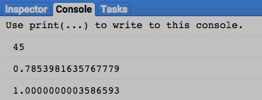

[GOOGLE EARTH ENGINE](EE01%20Earth%20Engine%20(EE).docx) [APPLICATION PROGRAMMING INTERFACE](EE05%20%20%20The%20EE%20API.docx) [CAPABILITIES](EE07%20%20%20%20%20%20API%20Capabilities.docx)

**TRANSFORMING** NUMBER [VARIABLES](EE13%20%20%20%20%20%20%20%20%20Variables.docx) WITH **TRIGONOMETRIC** OPERATIONS

number.atan2 creates a new number by calculating the arctangent (angle whose tangent matches the ratio of) two specified numbers: numerator over denominator.

newNumber = 1stNumber.atan2( 2ndNumber )

The specified numerator

The specified denominator

The new number

var FirstNUMBER = ee.Number( 0 );

var SecondNUMBER = ee.Number( 1 );

var RadianNUMBER = FirstNUMBER.atan2(SecondNUMBER);

var DegreeNUMBER = RadianNUMBER.multiply( 57.2957795 );

print ( RadianNUMBER, DegreeNUMBER );

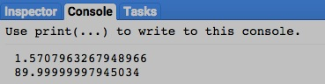

[GOOGLE EARTH ENGINE](EE01%20Earth%20Engine%20(EE).docx) [APPLICATION PROGRAMMING INTERFACE](EE05%20%20%20The%20EE%20API.docx) [CAPABILITIES](EE07%20%20%20%20%20%20API%20Capabilities.docx)

**TRANSFORMING** NUMBER [VARIABLES](EE13%20%20%20%20%20%20%20%20%20Variables.docx) WITH **BITWISE** OPERATIONS

number.bitwiseAnd , .bitwiseOr , .bitwiseXor , .bitwiseNot

all create a new number by applying

a specified bitwise function to two specified numbers.

.bitwise_and , .bitwise_or , .bitwise_xor , and .bitwise_not

newNumber = 1stNumber.bitwiseAnd( 2ndNumber ) or .bitwiseOr( ) or .bitwiseXOr( ) or .bitwiseNot( )

or .bitwise_and( ) or .bitwise_or( ) or .bitwise_xor( ) or .bitwise_not( )

The second specified number

The first specified number

The specified bitwise function

The new number

var FirstNUMBER = ee.Number( 1 );

var SecondNUMBER = ee.Number( 2 );

var BothBitNUMBER = FirstNUMBER.bitwiseAnd( SecondNUMBER );

var EitherBitNUMBER = FirstNUMBER.bitwise_or( SecondNUMBER );

print ( 'Bitwise 00000001 (=1) and 00000010 (=2) yields 00000000 = ', BothBitNUMBER );

print ( 'Bitwise 00000001 (=1) or 00000010 (=2) yields 00000011 = ', EitherBitNUMBER );

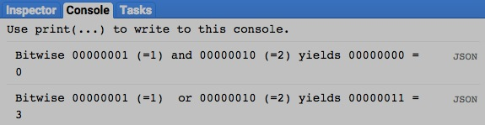

[GOOGLE EARTH ENGINE](EE01%20Earth%20Engine%20(EE).docx) [APPLICATION PROGRAMMING INTERFACE](EE05%20%20%20The%20EE%20API.docx) [CAPABILITIES](EE07%20%20%20%20%20%20API%20Capabilities.docx)

**TRANSFORMING** NUMBER [VARIABLES](EE13%20%20%20%20%20%20%20%20%20Variables.docx) WITH **BITWISE** OPERATIONS

number.leftShift , .rightShift , left_shift , and .right_shift create a new number by shifting the bits of a specified number

left or right by a specified amount.

newNumber = oldNumber.leftShift( numberOfPositions ) or .rightShift( )

The specified amount, given as an integer referring to bit positions

The specified number

The new number

The specified function, indicating whether bits are to be shifted left or right

var OriginalNUMBER = ee.Number( 8 );

var LeftwardNUMBER = OriginalNUMBER.leftShift( 1 );

var RightwardNUMBER = OriginalNUMBER.rightShift( 1 );

print( 'Left-shifted 8 =', LeftwardNUMBER );

print( 'Right-shifted 8 =', RightwardNUMBER );

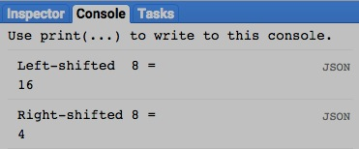

[GOOGLE EARTH ENGINE](EE01%20Earth%20Engine%20(EE).docx) [APPLICATION PROGRAMMING INTERFACE](EE05%20%20%20The%20EE%20API.docx) [CAPABILITIES](EE07%20%20%20%20%20%20API%20Capabilities.docx)

**COMPARING** NUMBER [VARIABLES](EE13%20%20%20%20%20%20%20%20%20Variables.docx)

ee.Algorithms.IsEqual creates a new Boolean set to True (only) if the first of two specified numbers is identical to the other in both structure and content.

newBoolean = ee.Algorithms.IsEqual ( 1stNumber, 2ndNumber )

The first specified number

The second specified number

The new Boolean

var FirstNUMBER = ee.Number( 123 );

var SecondNUMBER = ee.Number( 123.0 );

var TrueOrFalse = ee.Algorithms.IsEqual( FirstNUMBER, SecondNUMBER );

print( FirstNUMBER, SecondNUMBER );

print('Is it true or false that those two numbers are equal?' );

print( TrueOrFalse );

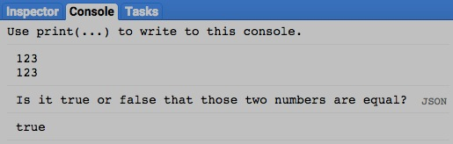

[GOOGLE EARTH ENGINE](EE01%20Earth%20Engine%20(EE).docx) [APPLICATION PROGRAMMING INTERFACE](EE05%20%20%20The%20EE%20API.docx) [CAPABILITIES](EE07%20%20%20%20%20%20API%20Capabilities.docx)

**DOCUMENTING** NUMBER [VARIABLES](EE13%20%20%20%20%20%20%20%20%20Variables.docx)

ee.Algorithms.Describe , ee.Algorithms.String , and number.getInfo

each creates a JSON-compatible text object

representing a specified number.

newObject = ee.Algorithms.Describe ( oldNumber )

ee.Algorithms.String( oldNumber )

and oldNumber.getInfo( )

The specified number

The new object

var OldNUMBER = ee.Number( 123 );

print( 'New string from the original number', OldNUMBER );

print( 'New string from ee.Algorithms.Describe', ee.Algorithms.Describe( OldNUMBER ) );

print( 'New string from ee.Algorithms.String', ee.Algorithms.String( OldNUMBER ) );

print( 'New string from string.getInfo( )', OldNUMBER.getInfo( ) );

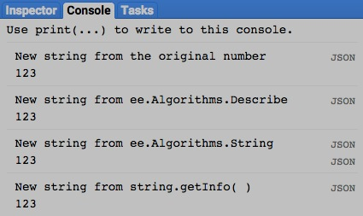

[GOOGLE EARTH ENGINE](EE01%20Earth%20Engine%20(EE).docx) [APPLICATION PROGRAMMING INTERFACE](EE05%20%20%20The%20EE%20API.docx) [CAPABILITIES](EE07%20%20%20%20%20%20API%20Capabilities.docx)

**DOCUMENTING** NUMBER [VARIABLES](EE13%20%20%20%20%20%20%20%20%20Variables.docx)

number.toString and .serialize each creates a new string presenting information on a specified number.

newString = oldNumber.toString ( )

and oldNumber.serialize( )

The specified number

The new string

var OldNUMBER = ee.Number( 123 );

print( 'New string from the original number', OldNUMBER );

print( 'New string from string.toString( )', OldNUMBER.toString( ) );

print( 'New string from string.serialize( )', OldNUMBER.serialize( ) );

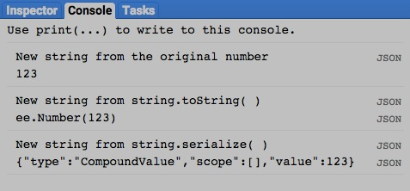

[GOOGLE EARTH ENGINE](EE01%20Earth%20Engine%20(EE).docx) [APPLICATION PROGRAMMING INTERFACE](EE05%20%20%20The%20EE%20API.docx) [CAPABILITIES](EE07%20%20%20%20%20%20API%20Capabilities.docx)

**PRESENTING** NUMBER [VARIABLES](EE13%20%20%20%20%20%20%20%20%20Variables.docx) IN **PRINT**

print ( number ) and console.log ( number ) present the text representation of a specified number in the console.

print( oldNumber ) or console.log( oldNumber )

The specified number

print( 123 );

console.log( 123 );

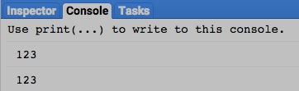

[GOOGLE EARTH ENGINE](EE01%20Earth%20Engine%20(EE).docx) [APPLICATION PROGRAMMING INTERFACE](EE05%20%20%20The%20EE%20API.docx) [CAPABILITIES](EE07%20%20%20%20%20%20API%20Capabilities.docx)

**PRESENTING** NUMBER [VARIABLES](EE13%20%20%20%20%20%20%20%20%20Variables.docx) IN **PRINT**

alert ( number ) and confirm( number ) presents the text representation of a specified number in a pop-up message box.

alert( oldNumber ) or confirm( oldNumber )

The specified number

alert( 123 );

confirm( 123 );

